POSTGRADUATE DENTAL IMPLANT EDUCATION

THE MASTER TUTOR
FROM TREATMENT PLANNING, laboratory hands-on, cadaver session to live surgery& certification
TO LIVE SURGERY

IN ORAL IMPLANTOLOGY

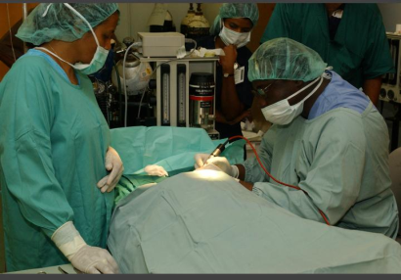
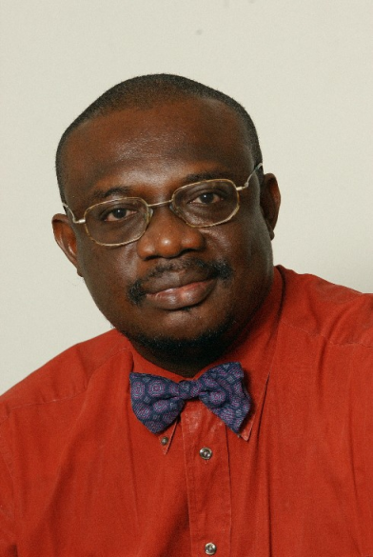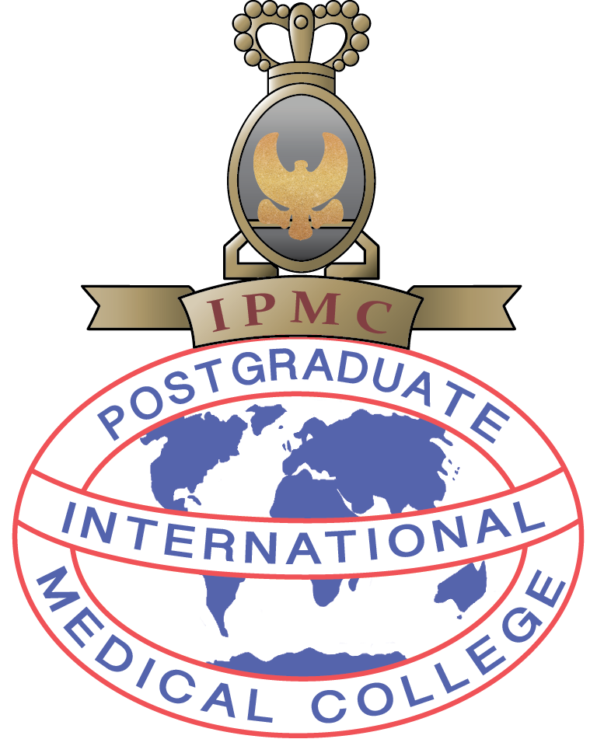

Dr Christopher Ogunsalu. MBBS, BDS, FRACDS, FWACS, FICS, FICD, MSc.Med(Lon), PhD( UWI)
Fellow American College of Oral & Maxillofacial Surgeons
Diplomat International Congress of Oral Implantologist
Director Dental Institute of the Caribbean
Senior Lecturer – Basic Medical Sciences, Faculty of Medical Sciences, University of the West Indies, Mona, Kingston Jamaica
Founder, International Postgraduate Medical College

20,000 USD – MSc Degree Program

INTERNATIONAL POSTGRADUATE MEDICAL COLLEGE

MSc. Oral Implantology (Full-time)

– 3 Semester Programme (Combined Virtual learning and direct contact Laboratory and clinical work with Research Component).

Who can apply?

Dentists with DDS, DMD or BDS

Programme Director
Dr Christopher Ogunsalu. MBBS, BDS, MSc.Med (Lon), FRACDS, FICD, FWACS, FICS, PhD
Fellow American College of Oral & Maxillofacial Surgeons

Tuition – 20,000USD

Semester 1

Impl 101- Introduction to Implant logy
Impl 102- Introduction to Bone grafting and Bone regeneration
Impl 103 Basic Principles of Implantology and Paper writing
Impl 104 – Bone Biology and Bone Regeneration Module
Impl 105- Laboratory Hands-on I (Virtual)
Impl 106 – Clinical Implantology – Level1 (Perio case, Implant Case Restorative case)
Impl 107 – E- Distance learning Module/ Tutorials
Impl108 – Virtual Cadaver session

Semester 2

Impl 201- Laboratory Hands-on II
Impl 202 - Advanced Bone Regeneration- E Distance learning, direct Teaching
Impl 203 - Residential Course Module (Minimum of 6 continuous Days with 8 hours teaching per day
Impl 204- Instrumentation
Impl 205- Complex GTR and the Sandwich Bone Regeneration Technique

Semester 3

Impl 301- Complex Technique in Implantology (Ridge split, Maxillary sinus lift techniques and Peri-implant Bone grafting)

Impl 302 – External Rotation

Impl 303 - Thesis
Thesis submission – Systematic review of the Literature.

Application Requirements

Admissions Office
INTERNATIONAL POSTGRADUATE MEDICAL COLLEGE

Tel: 876 632 7618

The College will need your application form filled together with the following;

1. 4 passport photo
2. Copy of birth certificate
3. Written letter as to why you want to do the MSc in Implantology.
4. Transcript (this can be submitted later).

COURSE PACKAGE

Course Fee includes the Following:

- E Books in Laptop
- E Books I Tablets
- Implant Surgical Motor
- Implant Restorative Kit
- 20 Implant
- 20 Abutment

APPLICATION FORM-MSc. ORAL IMPLANTOLOGY

Dual MSc Degree in Implantology: International Postgraduate Medical College

NAME:
______________________________________________________

ADDRESS:
City State:
Zip
Country:
Telephone: Fax:
Email
QUALIFICATION:
Degree:
Year:
Specialty: Year:
COURSE FEE: 20,000 US$

METHOD OF PAYMENT: Please make your cheque payable to Cornwall Dental Centre
Master Card
Visa
Card Number _________________________________________________________________
--------------------------------------------------------------------------------------------------
Expiration Date:
--------------------------------------------------------------------------------------------------
Signature:
__________________________________________________________________
How did you hear about us?
______________________________________________________________
Please print your name (as you wish it to appear on certificate)
You may also call Dr Ogunsalu on WhatsApp # 1876 405 8615 or Email chrisogun@yahoo.com
______________________________________________________________

