Caribbean Dental Implant Course for the Mastering of Implant Placement
Faculty of Dentistry- International Postgraduate Medical College

Course Components:

- E-Distance learning on:
- Zoom
- Tablet.
- Direct Contact Teaching (Power Point Lectures)
- Laboratory Hands-on by both:
- E-distance learning
- Direct Laboratory supervision
- Cadava Session
- Live Surgery- Real life Implant surgery.

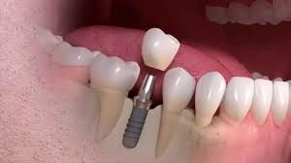
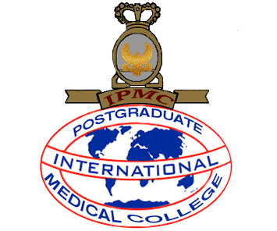

One –One Dental Implantology Training
DATE- DECEMBER 2021
Montego Bay & Kingston- Jamaica

Course Fee: 6,000 USD
To apply: Email: internationalpostgradmed@gmail.com or Call/WhatsApp: 876-287-8777 &internationalpostgradmed@gmail.cominternationalpostgradmed@gmail.cominternationalpostgradmed@gmail.cominternationalpostgradmed@gmail.com

Course Date: March 20- March 27, 2019

At the end of the course, applicants can begin placing implants and become eligible for ICOI Fellowship.
Course Director: Dr Christopher Ogunsalu. MBBS,BDS,FRACDS,FWACS,FICS,FICD,MSc.Med(Lon),PhD, LLB
Fellow American College of Oral & Maxillofacial Surgeons
Diplomate- International Congress of Oral Implantologists.

Course Components:
- E-Distance learning on:
- Zoom
- Tablet.
- Direct Contact Teaching (Power Point Lectures)- One Dozen of Relevant Lectures
3. Laboratory Hands-on and Instrumentation - by both:
A. E-distance learning
B. Direct Laboratory supervision
4. Cadaver Session
5. Live Surgery- Real Life Implant Surgery

Part I
Day 1- One Dozen of Lectures
- Material Science relevant to Implantology
-Titanium
-Synthetic Bone
- Collagen Membrane
- Placement of Dental implant in virgin Bone
- Immediate implant placement I
- Immediate implant placement II
- Bone Grafting
- Bone Regeneration
- Basic Periodontal Surgery
- Advanced Periodontal Surgery
- Concept of Conversion
- The Ogunsalu Sandwich Bone regeneration technique
- The Osteotome Technique of sinus lift
- Ridge Split Technique

Day 2- Laboratory Hands-on and Instrumentation
A total of 50 stations with didactic teaching in an interactive manner and in a highly educationally oriented environment
Day 3 – Live Surgery
1. Single implant placement in the Anterior Maxilla
2. Single implant placement in the Anterior Mandible
3. Single implant placement in the Posterior Maxilla
4. Single implant placement in the Posterior Mandible
5 .Multiple implant placement in the maxilla and Mandible

Part II

Impl 101- Introduction to Implant logy
Impl 102- Introduction to Bone grafting and Bone regeneration
Impl 103 Basic Principles of Implantology and Paper writing
Impl 104 – Bone Biology and Bone Regeneration Module
Impl 105- Laboratory Hands-on I (Virtual)
Impl 106 – Clinical Implantology – Level1 (Perio case, Implant Case Restorative case)
Impl 107 – E- Distance learning Module/ Tutorials
Impl108 – Virtual Cadaver session

Part III
Impl 201- Laboratory Hands-on II
Impl 202 - Advanced Bone Regeneration- E Distance learning, direct Teaching
Impl 203 - Residential Course Module (Minimum of 6 continuous Days with 8 hours teaching per day
Impl 204- Instrumentation
Impl 205- Complex GTR and the Sandwich Bone Regeneration Technique

APPLICATION FORM-

Faculty of Dentistry: International Postgraduate Medical College

NAME:
______________________________________________________

ADDRESS/ CONTACT INFORMATION
City State:
Zip
Country:
Telephone: Fax:
Email
QUALIFICATION:
Degree:
Year:
Specialty: Year:
COURSE FEE: 6,000 USD

METHOD OF PAYMENT: Please make your Check payable to International Postgraduate Medical College COO

OROornwall Dental Centre

Signature:
__________________________________________________________________
How did you hear about us?
______________________________________________________________
Please print your name (as you wish it to appear on certificate)
You may also call Dr Ogunsalu on WhatsApp # 1876 405 8615 or Email chrisogun@yahoo.com

