POSTGRADUATE DENTAl EDUCATION

THE clinical competence test text in oral diseases
FROM DIAGNOSIS to TREATMENT and management in oral diseases up to membership
TO LIVE SURGERY

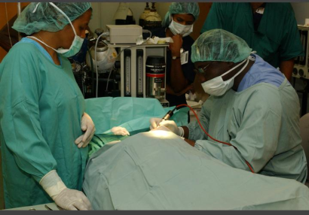


Dr Christopher Ogunsalu. MBBS, BDS, FRACDS, FWACS, FICS, FICD, MSc.Med(Lon), PhD( UWI)
Fellow American College of Oral & Maxillofacial Surgeons
Diplomat International Congress of Oral Implantologist
Director Dental Institute of the Caribbean
Senior Lecturer – Basic Medical Sciences, Faculty of Medical Sciences, University of the West Indies, Mona, Kingston Jamaica
Founder, International Postgraduate Medical College
Free!

- Explain the Differential Diagnosis of each of the lesions shown below.
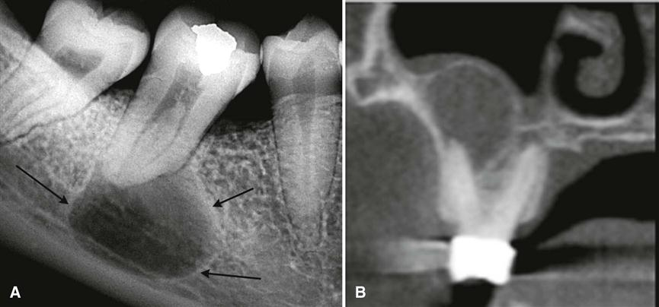

__________________________________________________________________________________________________________________________________________________________________________________________________________________________________________________________________________________________________________________________________________________________________________________________________________________________________________________________________________________________________________________________________________________________________________________________________________________________________________________________________________________________________________________________________________________________________________________________________________________________________________________________________________________________
20 Marks
- What type of biopsy would you do for the lesion?
_______________________________________________
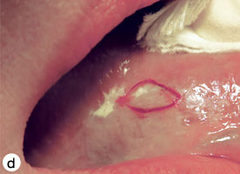
10 Marks

- What type of Biopsy would you do for the lesion shown below?
_______________________________________________________
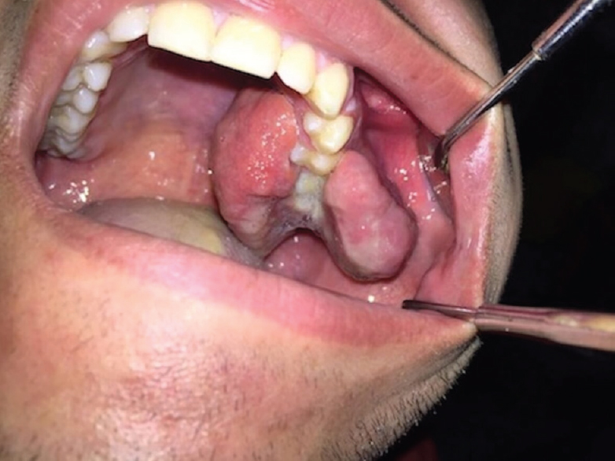
Explain your reason for the answer in # 2 and 3 - 20 Marks
_____________________________________________________________________________________________________________________________________________________________________________________________________

- What is this palate called?_____________________________________
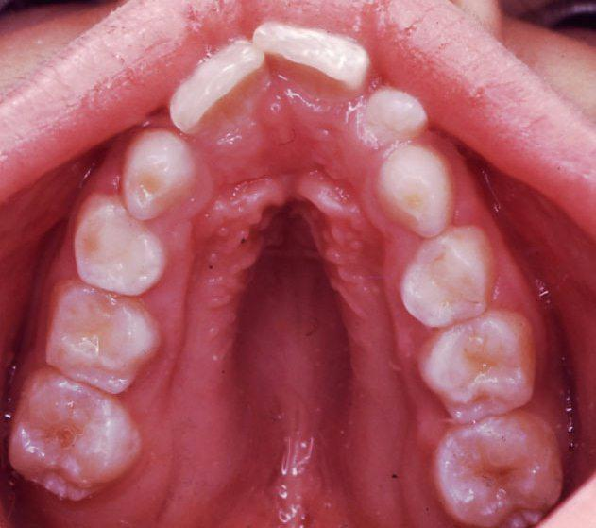
- Which condition has this appearance________________________________________?
- What is your diagnosis if this patient in addition to the above presentation has rethrognathia of the maxilla and mandible , roots dilacerations, pulp obliterations, high prevalence of TMJ Myofacial pain dysfunction syndrome, Aortic aneurysm and dissection, spontaneous pneumothorax, decreases lung compliance
_____________________________________________________
- What skeletal conditions or clinical manifestations( list 2) would you expect to see in this patient other than that seen in the picture shown above
i.
ii.
20 Marks

- The DPT below shows a well defined radiolucent lesion. Examine critically and make a choice of Diagnosis between Ameloblastoma and odontogenic keratocyst -
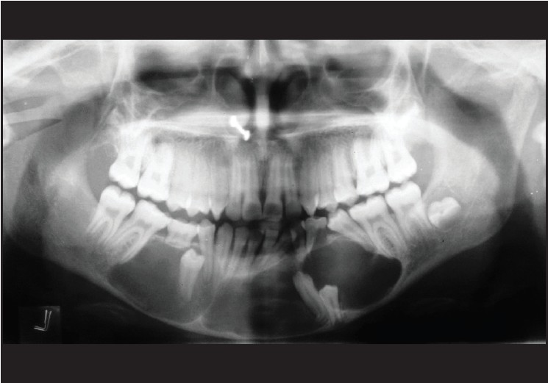
Mention 2 features which made you make the above mentioned choice: ( 20 Marks)
1.________________________________________2._________________________________
- List four differential diagnosis of this cheek lesion
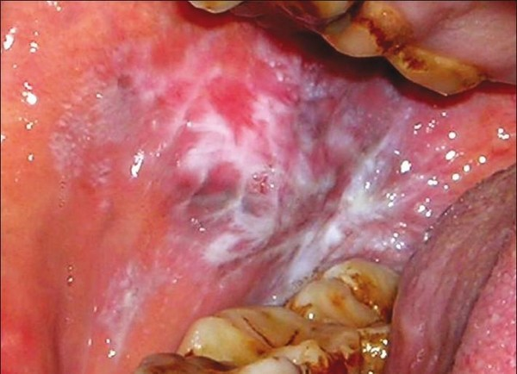
1.
2.
3.
4.
List the investigations of this lesion:
1.
2.
3.
4.
5. 20 Marks

- In the condition depicted schematically below, antibacterial chemotherapy coverage must be given prior to invasive dental procedure.
- What do we mean by invasive dental procedure
_______________________________________________________
- What is the recommended prophylaxis by the American Heart Association
______________________________________________________
- What is the recommended prophylaxis by the British Heart Association
___________________________________________________________
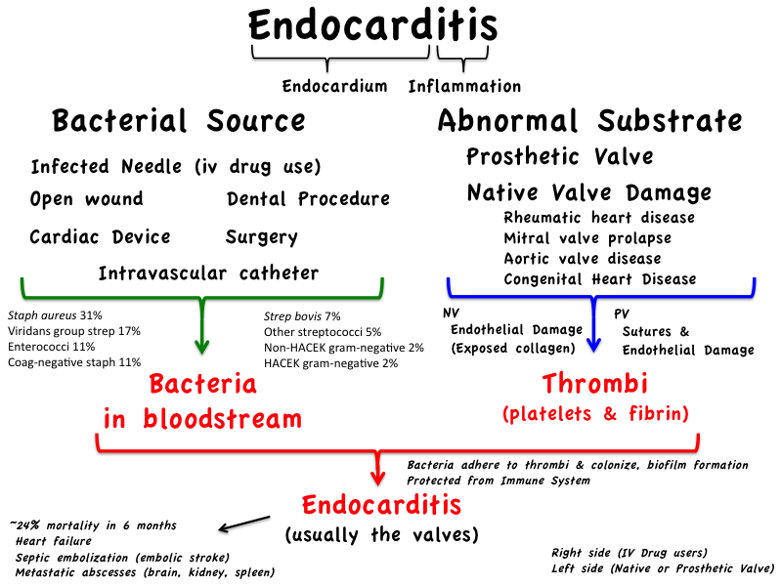
20 Marks
- What type of error is depicted in this DPT

Why is this so?
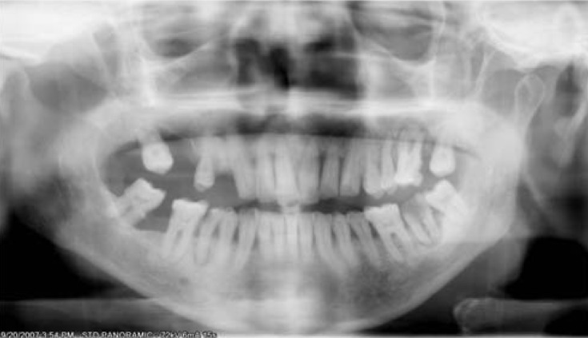

________________________________________________________________________________________________________________________________________________________________________________________________________________________________________________________________________________________________________________________
20 Marks

- The CT Reconstruction below shows multiple craniofacial osteomas.
Give one appropriate Diagnosis___________________________
List 2 other extra colonic manifestations
1.
2.
List 2 colonic manifestations
1.
2.

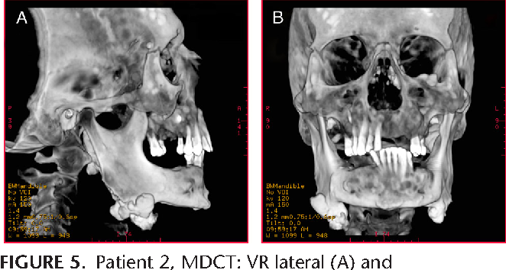
20 Marks

- Below is the St Augustine classification of Ameloblastoma.
Give the 3 (three) main Key words of this classification:
1.
2.
3

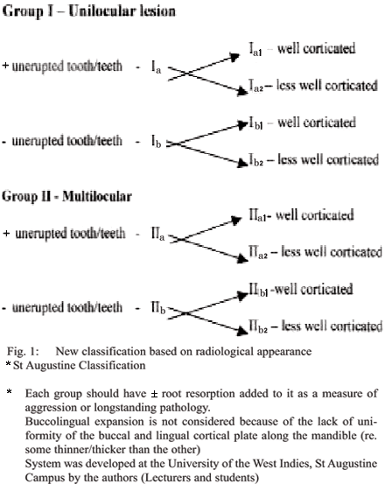
20 Marks

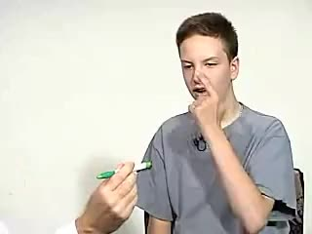
- The above patient is being tested for intentional tremor
List 4 causes of intentional tremor:
1.
2.
3.
4.
List 2 important significance of a tremor patient to Dental care.
1.
2.
(20 Marks)

- What kind of flap surgery is this________________________________
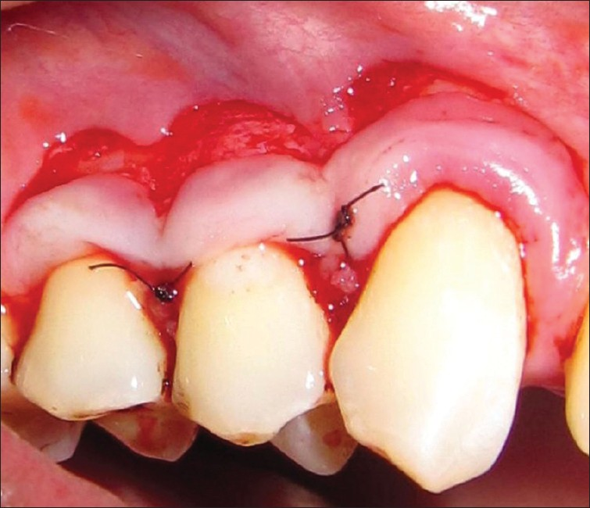
What kind of flap surgery will be appropriate for the management of this recession shown below? ________________________________________
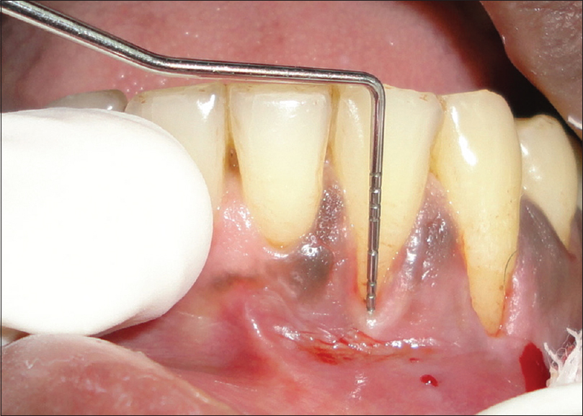
20 Marks

- List the different possible causes of the lesions seen below. The lesions are bloody
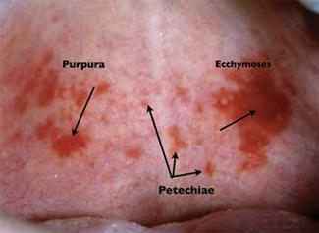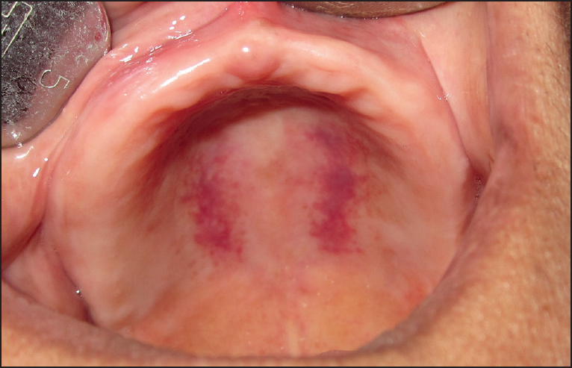
_______________________________________________________________________________________________________________________________________________________________________________________________________________________________________________________________________________________________________________________________________________________________________________________________________________________________________________________________________________________________________________________________________________________________________________________________________________________________________________________________________________________________________________________________________________________________________________________________________________________________________________________________________________________________________________________________________________________20 Marks
- This is an ultrasonographic aspiration of a fluid collection as shown below. Why do we have to do aspirations?
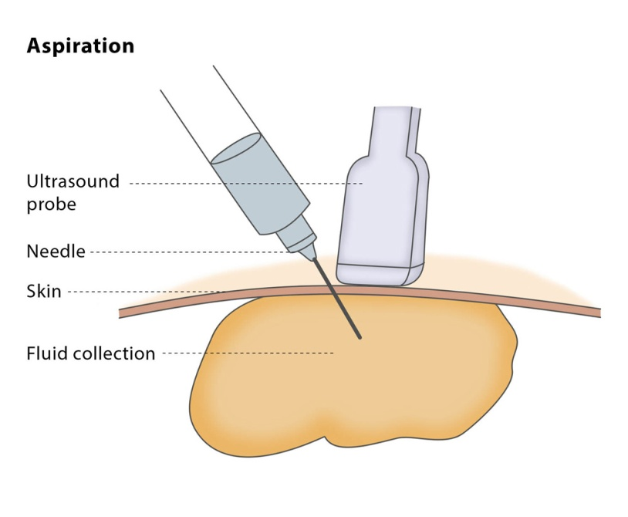
______________________________________________________________________________________________________________________________________________________________________________________________________________________________________________________________________________________________________________________________________________________________________________________________________________________________________________________________________________________________________________________________________________________________________________________________________________________________________________________________________________________________________________________________
___________________________________________________________________________________________________________________________________________________________________________________________________________________________________

- The illustration below is that of a patient who presented like this to the clinic 24 hours after receiving an injection of penicillin. He was normal prior to this.
- What is this called____________________________________
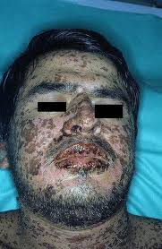
- What is the main stay of treatment for this condition
___________________________________________________________________________________________________________________________________________________________________________20 Marks
- Explain the lesions below
____________________________________________________________________________________________________________________________________________________________________________________________________________________________________________________________________________________________________________________________________________________________________________________________________________________________________________________________________________________
__________________________________________________________________________________________________________________________________________________________________________________________________________________________________________
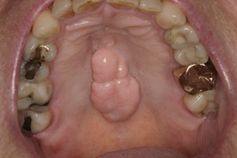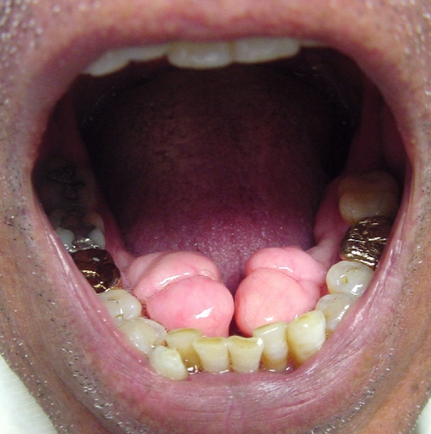
List the significance of these lesions. (20 Marks)
1.
2.
3.
4.

- The implant placement seen in the picture below is being placed in an extraction socket 3 weeks after extraction.
What is this called._____________________________________
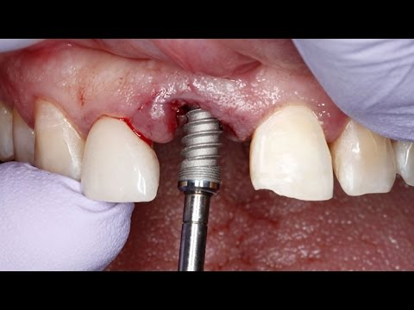
List the advantages of this type of implant placement
1.
2.
3.
4.

(20 Marks)
- This is the intraoral picture, after the removal of the fistulous tract which developed after the placement of implant 5-months ago. The implant was suctioned out by Dr Ogunsalu simple suctioning technique.
List 2 techniques to bone graft oro-antral communication
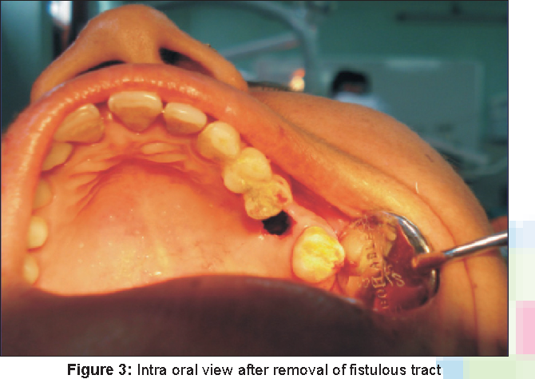
1.
2.
What are the advantages of each of these techniques?
1.
2.
3.
4.

20 Marks.
- The illustrations below and the footnotes describe a joint technique. Name each of these joint techniques?
1.
2.

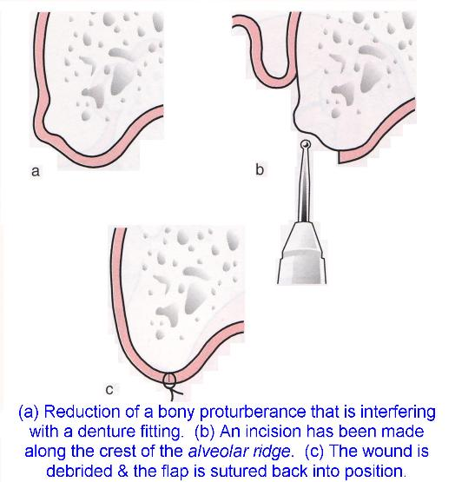
Is bone grafting inevitable____________?

Is suturing mandatory? ______________

20 Mark
- The radiograph below shows an increasingly used 3rd molar technique. What is this technique called____________________________________
Name the USA based professor who popularized this technique
_______________________________________
What are the advantages of this technique?
1.
2.
3.
4.
What are the disadvantages of this technique?
1.
2.
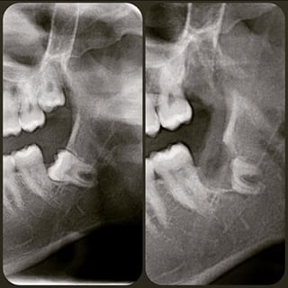20 Marks

- The patient shown below is undergoing 3rd molar extraction ( four 3rd molars ) under sedation at the International Postgraduate Medical College Oral surgery clinic.
- Write the prescription of the sedative cocktail
________________________________________________________________________________________________________________________________________________________________________________________________________________________
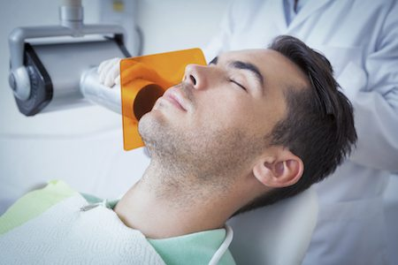
- What is the major central nervous system effect of this cocktail
- What major precaution will you take when discharging this patient

20 Mark
- Based on this radiologic presentation shown below, what is your diagnosis( name only one)_______________________________
Mention 2 reasons for choosing this diagnosis:
1.
2.

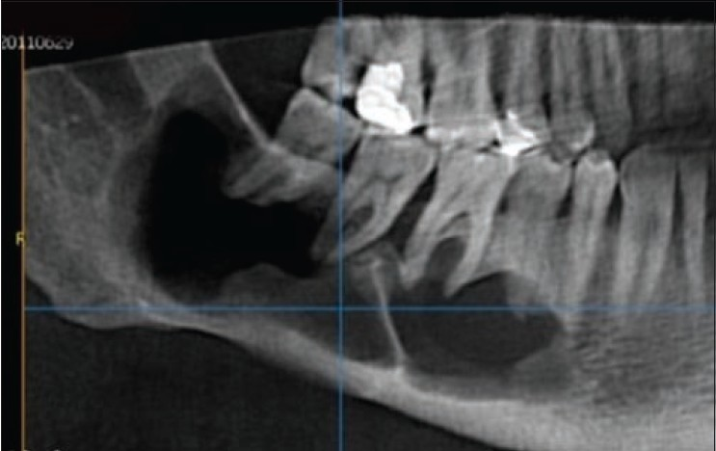10 Marks

- What is your histological diagnosis of this photomicrograph_________
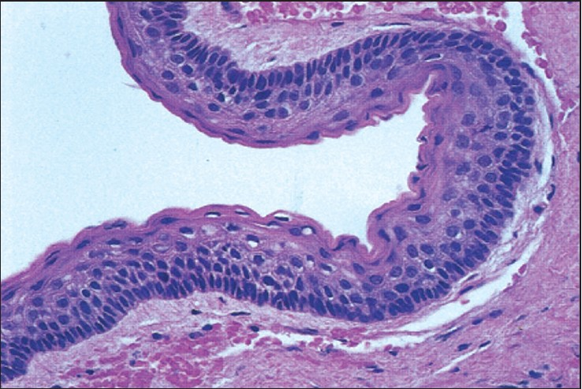
Would you do immunocytochemistry______________Why? 10 Marks
- This patient has TMJ Myofacial pain dysfunction syndrome.
Outline her investigations
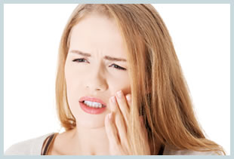

- Outline the possible managements and treatments for the patient shown in Q.24 above.(20Marks)

- What is this clinical presentation called.___________________________
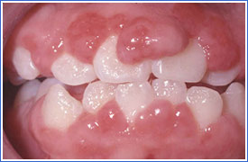
Outline the various possible causes:
1.
2.
3.
4.
5
- For the patient mentioned in # 26 above, outline the possible surgical management.

20 Marks

- The finger points into the infratemporal fossa. What is the inferior boundary of this fossa
___________________________________________________________(10 Marks)
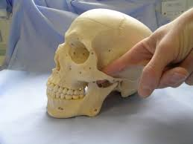
- As it relates to the periapical radiograph below, if the 1st molar is tender to apical and lateral percussion, what is the diagnosis.
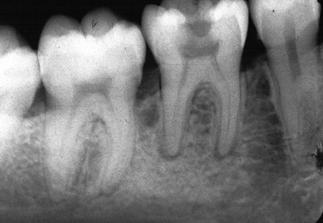
____________________________________________________________________(10 Marks)
- What is your diagnosis of the intra-oral lesion below:
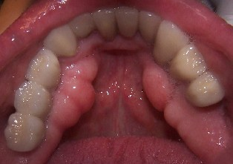

How many studies have been done on these type of lesions in the English-speaking Caribbean_________

List these studies:
1.
2.
3
4.

20 Marks

